**Upload Flat File Zip and Moved to Archived folder than delete from Source folder:**

**Folder Name:**

Source: To store csv files that we want to upload

Archive: moved files into this folder after upload

**File Name:** Employee01.txt, Employee02.txt

**Database:** Northwind

Table: Create table using

IF OBJECT_ID('dbo.Test_Employees', 'U') IS NOT NULL DROP TABLE dbo.Test_Employees

GO

CREATE TABLE [dbo].[Test_Employees](

[EmployeeID] [int] IDENTITY(1,1) NOT NULL,

[LastName] [nvarchar](50) NOT NULL,

[FirstName] [nvarchar](50) NOT NULL,

[Title] [nvarchar](10) NULL,

[BirthDate] [datetime] NULL,

[Address] [nvarchar](100) NULL,

[City] [nvarchar](50) NULL,

[Region] [nvarchar](20) NULL,

[PostalCode] [nvarchar](10) NULL,

[Country] [nvarchar](20) NULL

) ON [PRIMARY]

GO

**Connection String:**

File Connection: You need one connection to .txt files

Database Connection: You need one connection to link to database

**Parameters:**

1. pSourceFolder (Data type: String): \\LAPTOP-E1J6KUU3\TechnicalExp\SSIS\Edge\Source\

2. pArchiveFolder (Data type: String): \\LAPTOP-E1J6KUU3\TechnicalExp\SSIS\Edge\Archive\

**Variables:**

3. vEmployee (Data type: String): Leave it blank (To use for Employee01.txt, Employee02.txt files)

**Create Project:**

1. You can create new project and chose the name of your choice or you can add new Package into existing project “UploadFlatFileIntoTable” and called it “0002Edge_LoadFileZipAndDelete.dtsx”

2. Control Flow:

2.1 Add Execute SQL Task and add following script to create “Test_Employees” table into Northwind DB using Northwind Connection Manager

2.2 Add “Foreach Loop Container” and double Click on it.

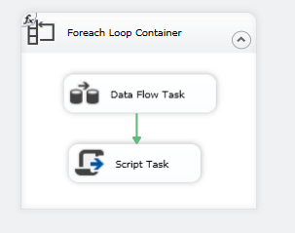

We have use parameter for Source folder

pSourceFolder (Data type: String): \\LAPTOP-E1J6KUU3\TechnicalExp\SSIS\Edge\Source\

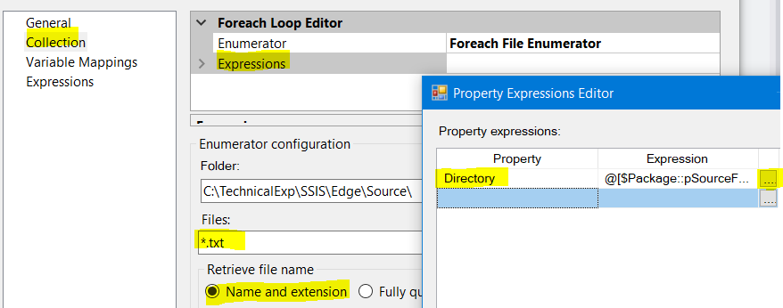

2.3 Add new variable vEmployee and leave the file name blank

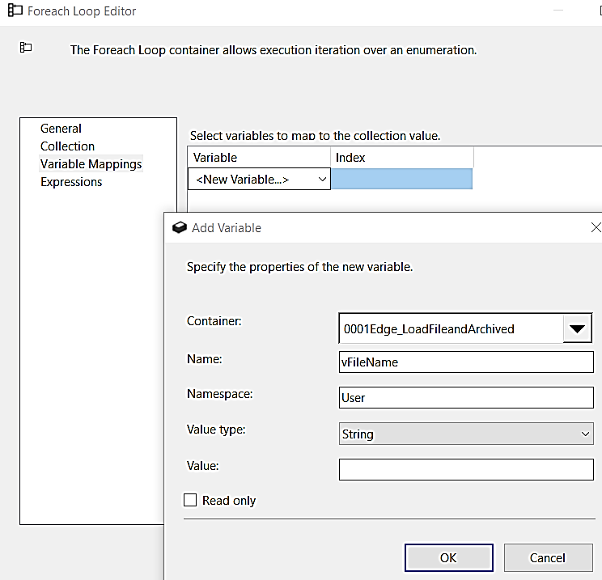

3. Add [Data Flow] task into Foreach Loop Container

3.1 Double Click on [Data Flow Task] and add [Flat File Source]

3.2 Create Flat file connection for Employee.txt files (01, 02), just pick one file for connection, If mapping error occurs than Right Click – Edit – Advance – Select data type for the column that show error

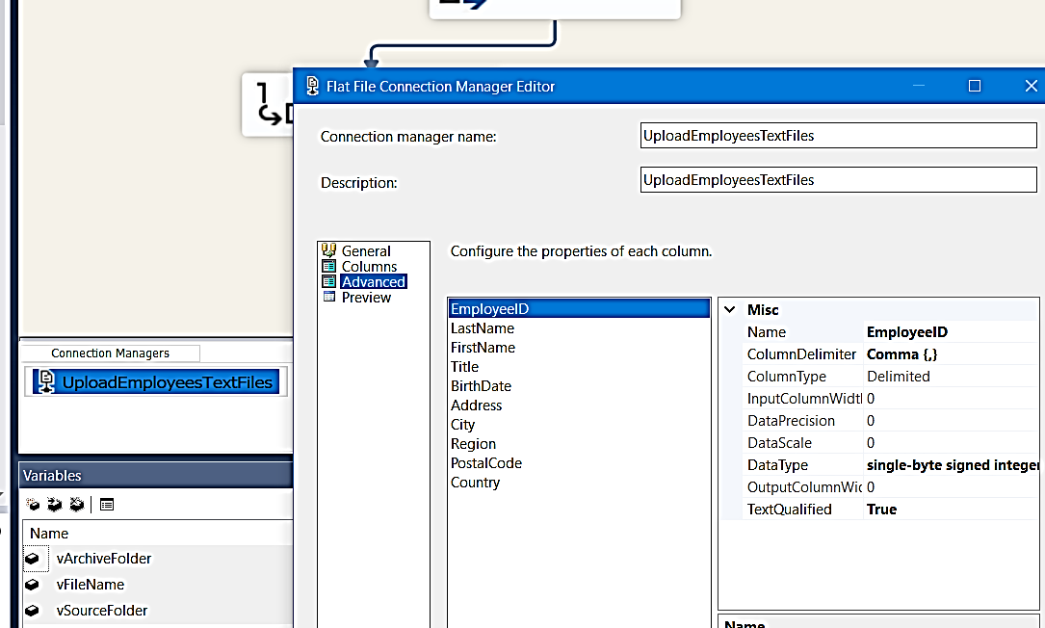

4. Add [OLE DB Destination] to upload data into Test_Employees table, for this you need Connection Manager to Northwind database, we already have one so we will use it.

5. If there is problem mapping data you have to go back 3.2

6. Right Click on Flat File Connection Manager – Properties – Select Expressions – connection String and use pSourceFolder + vEmployee to define full path with file name

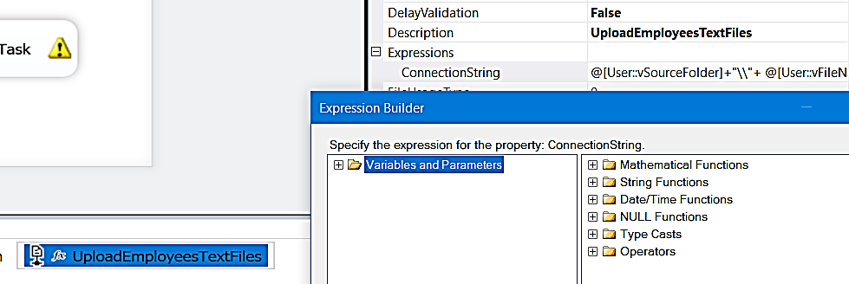

7. Package is ready you can run now – F6

8. Now Add Script task to make Zip file and then delete using C# Code

Note: In .NET 4.5 framework we have System.IO and System.IO.

8.1 Drag and Drop Scrip Task into Foreach Loop Task

8.2 Double Click to open it and add Parameters and variables that we need.

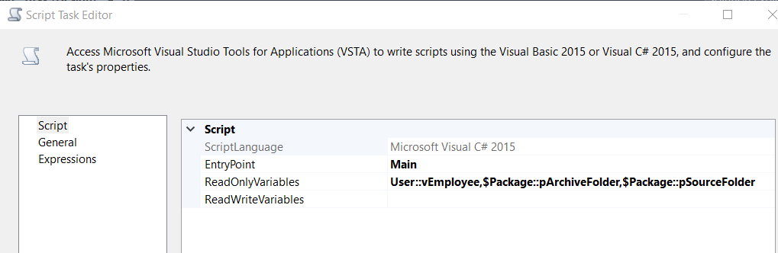

8.3 click on “Edit Script” to add Assemblies and write C# code

8.4 Make sure you have Selected .NET framework 4.5

Under [Solution Explorer] Right Click solution – [Properties] – Target framworks select “.NET framework 4.5 in order to use IO Compression to make Zip file

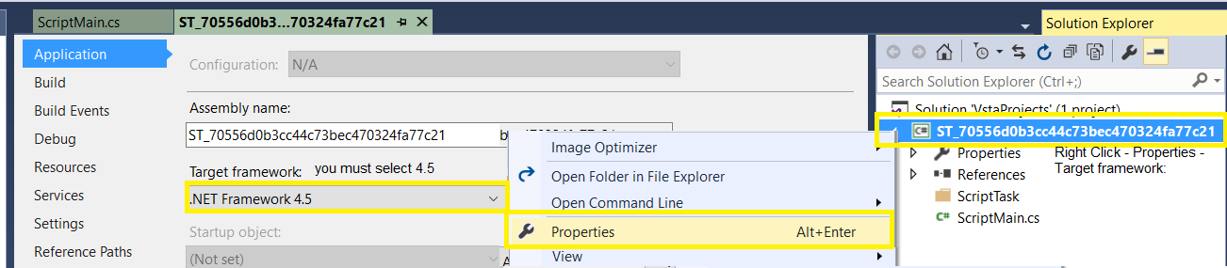

8.5 Now under [Solution Explorer] – References – [Right Click] Add following two Assemblies

System.IO.Compression and System.IO.Compression.FileSystem

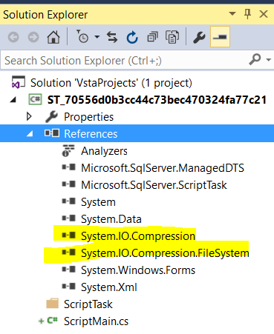

8.6 Now go to ScriptMain.cs and the following code

#region Namespaces

using System;

using System.Data;

using Microsoft.SqlServer.Dts.Runtime;

using System.Windows.Forms;

using System.IO;

using System.IO.Compression;

#endregion

namespace ST_70556d0b3cc44c73bec470324fa77c21

{

[Microsoft.SqlServer.Dts.Tasks.ScriptTask.SSISScriptTaskEntryPointAttribute]

public partial class ScriptMain : Microsoft.SqlServer.Dts.Tasks.ScriptTask.VSTARTScriptObjectModelBase

{

public void Main()

{

            // TODO: Add your code here

            string fileName = Dts.Variables["User::vEmployee"].Value.ToString();

            string fullSourcePath = Dts.Variables["$Package::pSourceFolder"].Value.ToString() + fileName;

            string fullArchivePath = Dts.Variables["$Package::pArchiveFolder"].Value.ToString() + fileName.Replace(".txt", ".Zip");

            using (ZipArchive zip = ZipFile.Open(fullArchivePath, ZipArchiveMode.Create))

            {

                zip.CreateEntryFromFile(fullSourcePath, fileName);

            }

            File.Delete(fullSourcePath);

            Dts.TaskResult = (int)ScriptResults.Success;

}

        #region ScriptResults declaration

        enum ScriptResults

        {

            Success = Microsoft.SqlServer.Dts.Runtime.DTSExecResult.Success,

            Failure = Microsoft.SqlServer.Dts.Runtime.DTSExecResult.Failure

        };

        #endregion

}

}

8.7 Close the project, then click OK on Scrip Task and F6 to execute the package.

Enjoy!!!

Project Deployed and run successfully..

